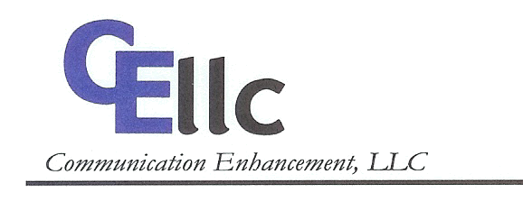

479 Centennial Blvd.
Voorhees, NJ 08043
Phone: 1-877-CELL-LLC
Fax: 1-856-782-3701

DIRECT DEPOSIT CHANGE OF BANK ACCOUNT/CONTACT INFORMATION

⁭ Change of Contact Information ⁭ Change of Bank Account Information

Old Bank Name: ___________________________________________________________
New Bank Name: ___________________________________________________________

Old Bank Address: __________________________________________________________
New Bank Address: _________________________________________________________

Old Account Name: __________________________________________________________
New Account Name: _________________________________________________________
(If account is not in your name, then please attach an explanation. We may not be able to offer this service under certain circumstances.)

Old Account No. _______________________
New Account No. _______________________

Old Routing No. _______________________
New Routing No. _______________________
(You may need to call your bank to obtain this information.)

Social Security # of individual whose name above account is in: ____________________

If the account is a savings account, please attach a copy of a recent bank statement to this form. If the account is a checking account, please attach a copy of a blank check marked “VOID.”

By signing below, you are agreeing to have your monthly rent payments from Communication Enhancement, L.L.C. made by Direct Deposit into the above bank account/above updated bank account.

_________________________________ _________________________________
Signature Date

To assist in updating our records, please provide your most recent contact information:

Home Telephone #: ___________________________________
Cell Phone #: ___________________________________
Home Address: ___________________________________
___________________________________
___________________________________

